Quarterly Chapter Report for
Beaver State Chapter #108

We had an extra special meeting this quarter. Amount other items we had a super duper talk on amateur radio digital modes by one of our members, Ron, N7HD, and we gave a 50 year QCWA certificate to two of our distinguished members, Del, W7ZQN, and Pete, K7YTM.
Ron has been using digital modes almost since the inception and is trying for his Work All Counties (WAC) award. He is coming close. All digital modes discussed included AMTOR, PACTOR, PSK31, and his favorite JT65. This was an outstanding presentation where we learned much and thank Ron a lot.

Pete has been active in amateur radio for over 50 years. He more then deserves this award since he active in RACES, ARES and QCWA. Congratulations to Pete.

We are looking forward to our next meeting. We will be visiting the Evergreen Aviation Museum, home of the Spruce Goose. They have a new Space Museum which houses, among other space items, a real Titan missile. Lunch will be served right on the museum floor overlooking all the WWII and experimental aircraft, and then will begin a powerful docent tour full of history and technology. There has been a great deal of enthusiasm for this meeting and I hope to see all of you there.

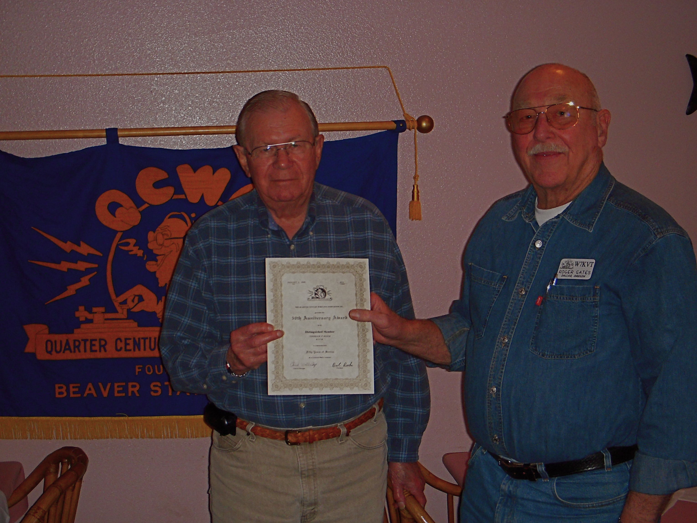

Figure 1. Pete Weber, K7YTM, receiving his 50 year certificate from our President, Roger, W7KVT.

Howard Honig, WB7OK
Secr/Treas
Beaver State Chapter 108

